Major Stakeholders Planning

|  |  |  |  |  |  |
| --- | --- | --- | --- | --- | --- |
| S.N. | Department | Ministries | Roles and Responsibility | Laws/Rules/Policy | Projects |
| 1 | Department of Water Supply and Sewerage (DWSS) | Ministry of Water Supply | to provide basic water supply and sanitation access, improved service levels in water supply | Rural water Supply and Sanitation Sector Policy 2004  National Urban Water Supply and Sanitation Policy 2009  National Water, Sanitation and Hygiene Master Plan 2011  Institutional and Regulatory Framework for FSM in Urban Areas of Nepal, 2017 | National Rural Water Supply and sanitation Improvement Project  Third Small Town Water Supply and Sanitation Sector Project |
| 2 | Department of Environment | Ministry of Forest and Environment | Implement, Monitor and Enforcement of the Environmental Activities | Environment Protection Act, 1997, Environment Protection Rules 1997, Constitution of Nepal 2015 |  |
| 3 | Department of Local Infrastructure Development and Agricultural Roads (DoLIDAR) | Ministry of Federal Affairs and Local Development | Undertake infrastructure development programs in coordination with concerned agencies and ensure quality. | Institutional and Regulatory Framework for FSM in Urban Areas of Nepal, 2017 | WASH Program funded by Government of Finland and UNICEF |
| 4 | Department of Urban Development and Building Construction (DUDBC) | Ministry of Urban Development | Develop sustainable urban settlement | Town Development act 1998  National Urban Development Strategy 2017 | New Town Project  Secondary Towns Integrated Urban Environmental Improvement Project  Integrated Urban Development Project |

Stakeholder based on Institutional and Regulatory Framework for FSM in Urban Areas of Nepal

* Ministry of Water Supply (MoWS)
* Ministry of Federal Affairs and Local Development (MoFLD)
* Department of water Supply and Sewerage (DWSS)
* National WASH Training Center (NWASH TC)
* Water Supply and Sanitation Division Office (WSSDO)
* Local Body
* Municipal Association of Nepal (MuAN)
* Water Supply Users Committee (WUSC)
* Supporting Agencies (I/NGO, Research Academy)
* Private Entrepreneurs

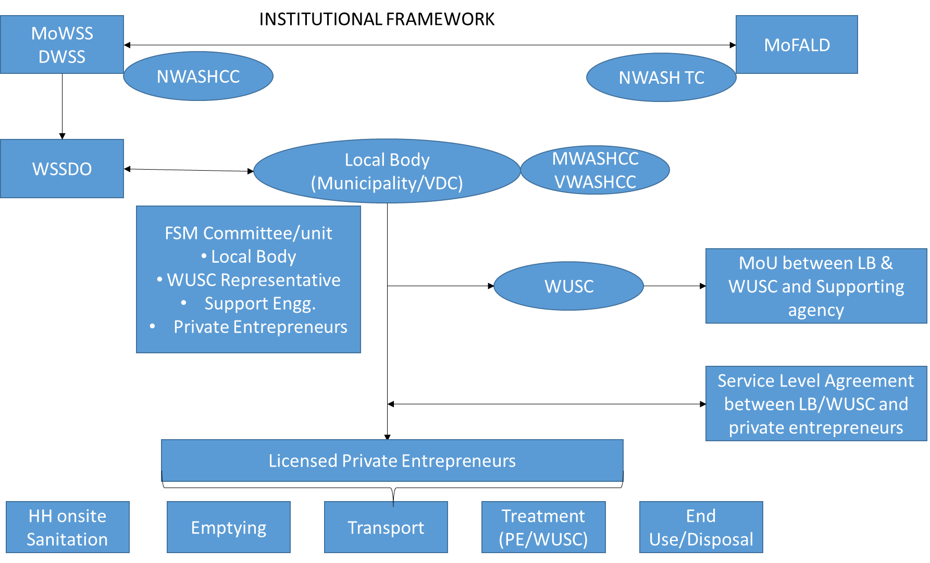

Some Interventions of FSM in Nepal

|  |  |  |  |
| --- | --- | --- | --- |
| S.N. | Year | Major Intervention | Stakeholders |
| 1 | 1999 | Construction of Teku Septage Treatment Plant (TSTP) | Kathmandu Metropolitan City (KMC), ENPHO |
| 2 | 2004 | Construction of Septage Treatment Plant in Pokhara | Pokhara Sub-metropolitan city, |
| 3 | 2011 | Status and Strategy for Faecal Sludge Management in the Kathmandu Valley | HPCIDBC, UN Habitat |
| 4 | 2014 | Study on Faecal Sludge Management in Kathmandu Valley | ENPHO, Bill & Melina Gates Foundation, |
| 5 | 2015 | Faecal Sludge Management in Panauti Municipality | ENPHO,WATER AID Nepal |
| 6 | 2015 | Assessment of FSM : Strategic Guidance for future investment in small town | ENPHO, USAID Nepal |
| 7 | 2015 | Faecal Sludge management in Nepal: Key Challenges and The Way Forward | MoUD, DWSS, Third Small Towns Water Supply and Sanitation Sector Project (Workshop) |
| 8 | 2016 | Faecal Sludge Treatment Plant at Lubhu | Mahalaxmi Municipality, ENPHO,OXFAM, CDD, BORDA |
| 9 | 2016 | Faecal Sludge Treatment Plant at Gulariya | Gulariya Municipality, ENPHO, Practical Action |
| 10 | 2017 | Feasibility Study on FSM for 10 municipalities | ENPHO, BORDA |
| 11 | 2017 | Institutional and Regulatory Framework for FSM in Urban Areas of Nepal | MoWSS |
| 12 | 2017 | Training on DEWATS and FSM | ENPHO, BORDA |
| 13 | 2018 | Training on Introduction to DEWATS and FSM for Municipalities inside Kathmandu Valley | ENPHO, MuAN, KU, IHE |